Chapter 10, Problem 40.

Find i_{o} in the circuit shown in Fig. 10.85 using superposition.

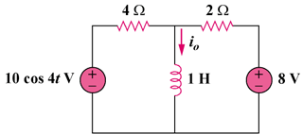

Figure 10.85
For Prob. 10.40.

